**Student Monetary System**

1. Kevin Mwenda - 101538
2. Jessie Kiriungi - 97004
3. Anthony Gitonga - 101985
4. Eric Burugu - 100036

**Process Description**

# Project Schedule

It is estimated that the application will take about 9 weeks to be built. The schedule is as described below.

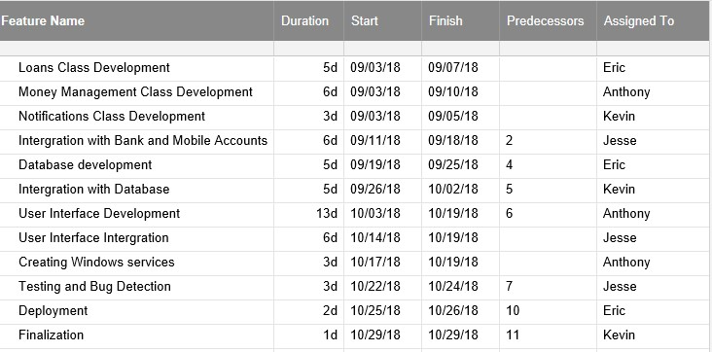

# Test Plan

Since our main programming language will be Java, our unit testing tool will be Junit. Our system integration testing will be done manually to ensure that external data brought into the system actually conforms with the system specifications. Our users will be responsible for usability testing. The system will enable users to report bugs and problems and also give suggestions on how to make the system more usable. Apart from that, the whole team will be responsible for ensuring that the user interface is as easy to use as possible. Junit will be used to test functionality of the loans class and money management classes. The test will be for validation and verification that outputs from the system are in correct format and are available. This will ensure that the system actually gives output. The tests will be developed by all members in the time specified in the project schedule. Unit tests will run automatically as long as program is running, and other tests will run periodically. System integration tests will run during system implementation.